Tasks and Deliverables: The client, one of the first-round funders, wants to know:
- When did Jean create this spreadsheet? (10 Marks)
Jean created the spreadsheet on 12/06/2008 at 18.13(6.13pm)
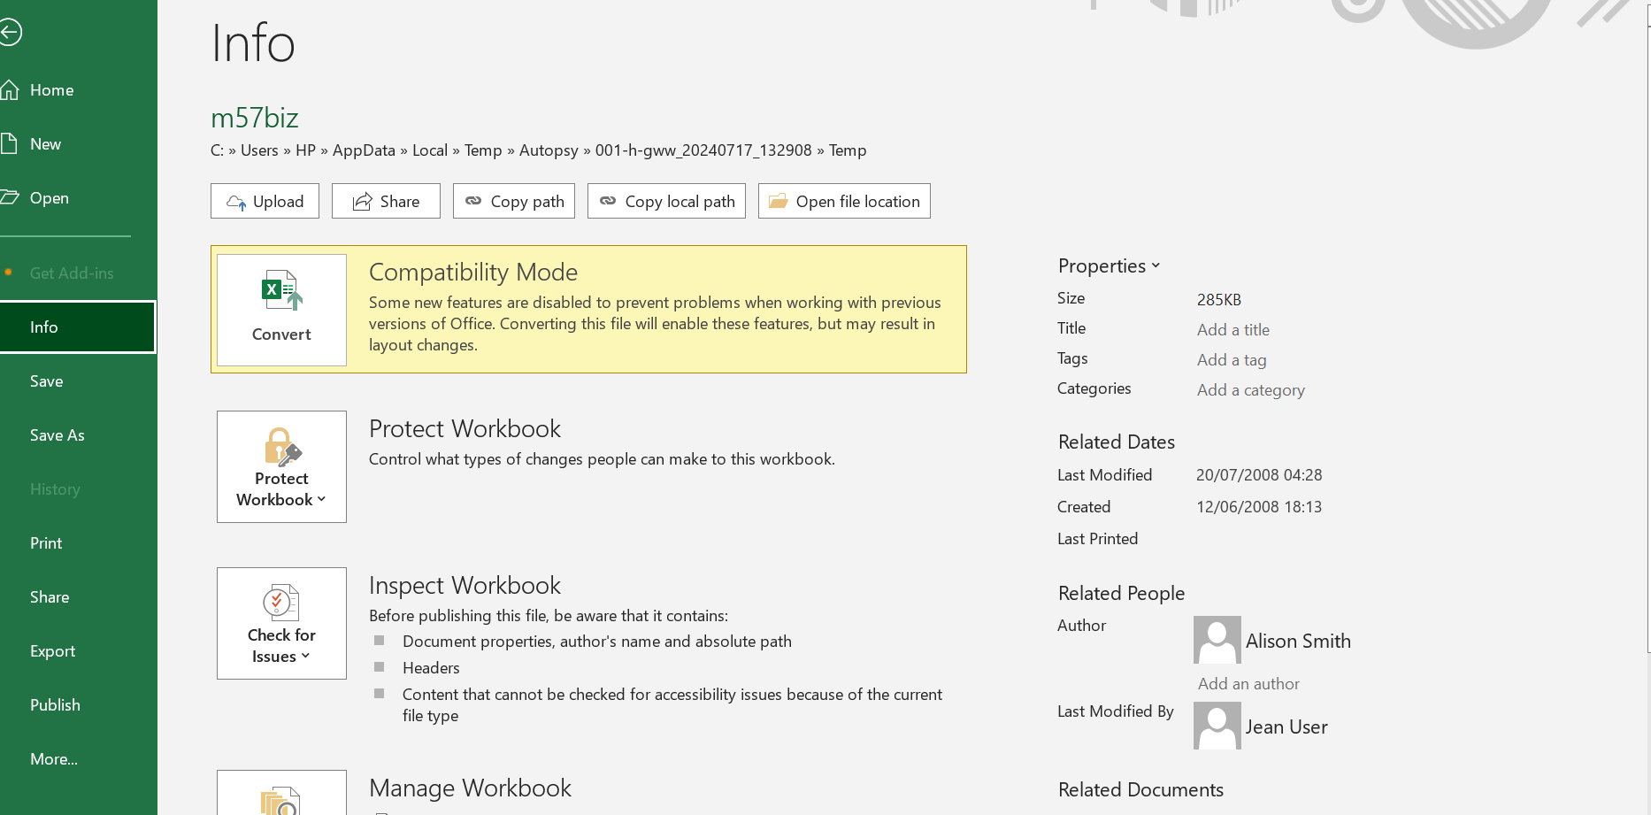
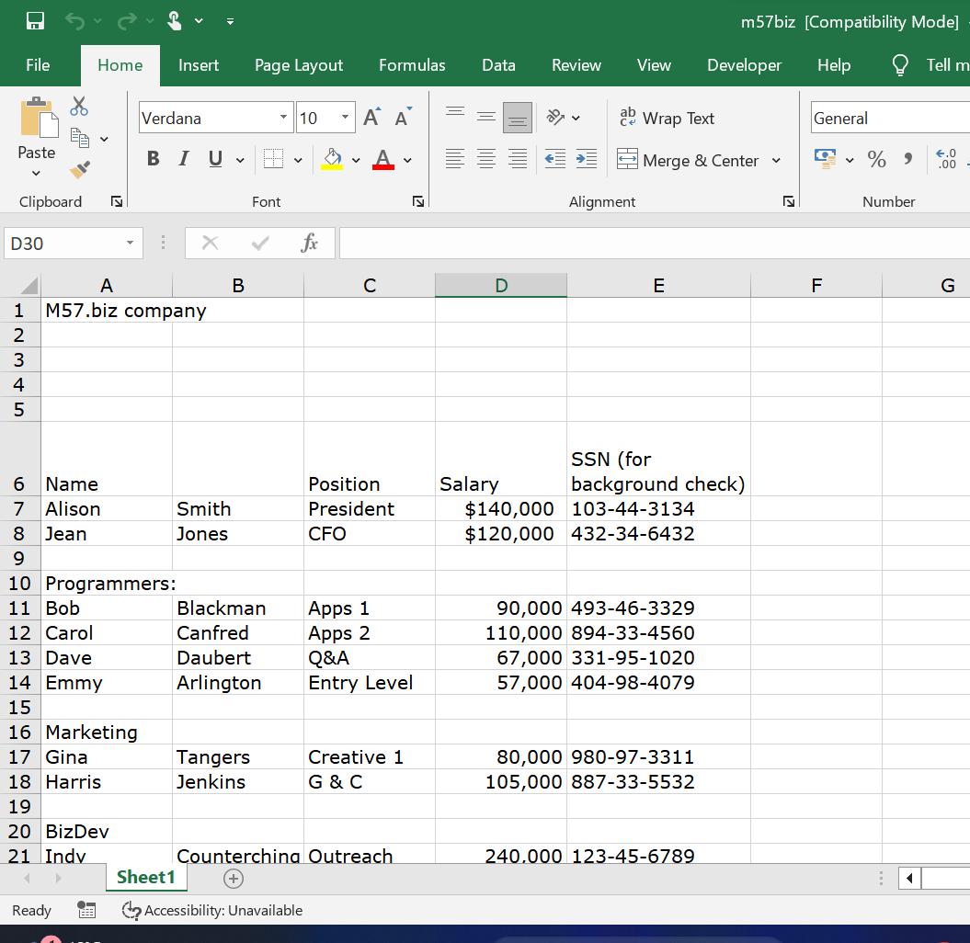
2. How did it get from her computer to competitor's website? (10 Marks)
From: alison@m57.biz [mailto:tuckgorge@gmail.com]
This is an email spoofing attack, tuck gorge disguised as Alison to ask for the information from Jean. Jean sent the information to tuck gorge thinking it was Alison who then posted it on the competitors website.

I've attached the information that you have requested to this email message.

-----Original Message-----
From: alison@m57.biz [mailto:tuckgorge@gmail.com]
Sent: Sunday, July 20, 2008 2:23 AM
To: jean@m57.biz
Subject: Please send me the information now

Hi, Jean.

I'm sorry to bother you, but I really need that information now --- this VC guy is being very insistent.
Can you please reply to this email with the information I requested --- the names, salaries, and
social security numbers (SSNs) of all our current employees and intended hires?

Thanks.

Alison

3. Who else from the company is involved? (10 Marks)
Alex was also involved, he asked Jean to put together financial projections.
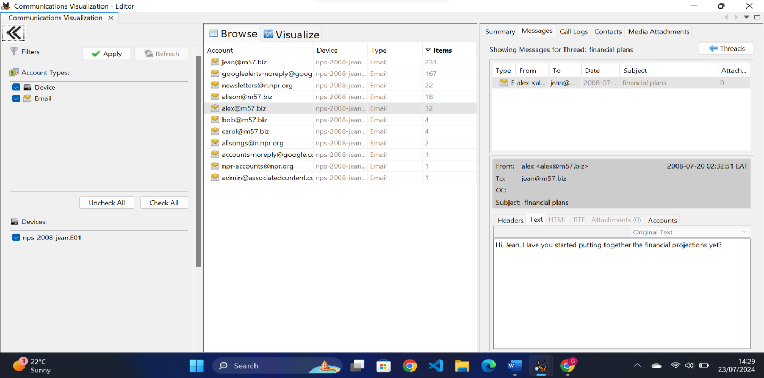
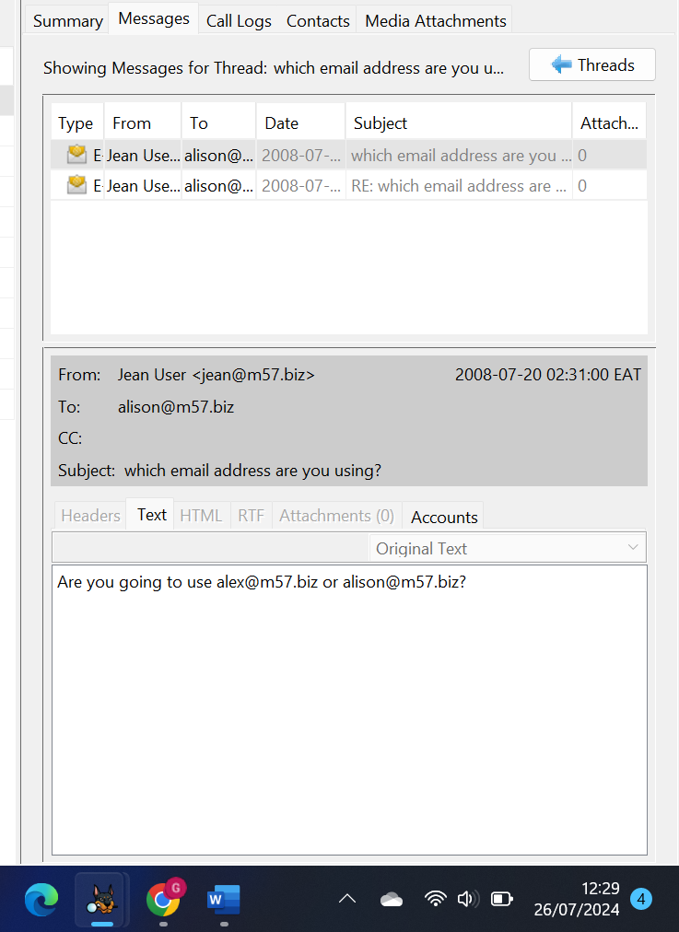
Jean was also confused asking which email address Alison was using.
4. Expert report (10 Marks)
EXPERT REPORT DATA BREACH INCIDENT

Introduction
This report details the investigation into the unauthorized disclosure of a confidential spreadsheet containing the names and salaries of the company's key employees. The spreadsheet was found posted on a competitor's website. The laptop of Jean, the CFO, was identified as the source of the leak. The investigation aimed to determine how the data was exfiltrated and whether Jean or others were involved.
Methodology
The investigation was conducted using the following forensic analysis tools:
- Autopsy was used to analyze the image of Jean’s hard drive.
- Email logs were reviewed to identify unauthorized data transfers.
Findings
Creation date of the spreadsheet: 12/06/2008 at 18.13(6.13pm)
The investigation revealed that the data was exfiltrated through an email spoofing attack. Key findings include:
Email Analysis: Jean received an email that appeared to be from Alison, the company president, requesting the confidential spreadsheet. The email address used was a spoofed address resembling Alison's official email.
Email Spoofing Attack: Jean, believing the email to be genuine, replied to the spoofed email and attached the confidential spreadsheet.
Unauthorized Transfer: The attackers, using the spoofed email address, received the spreadsheet and subsequently posted it on the competitor's website.
Conclusion
The data breach resulted from a targeted email spoofing attack on Jean. The attacker tricked Jean into sending the confidential spreadsheet by impersonating Alison's email address. This incident shows the importance of cybersecurity protocols, including enhanced email authentication measures and employee awareness training, to mitigate the risks associated with email-based attacks.

Recommendations
To prevent future incidents, the following measures are recommended:
- Email Authentication: Implement email authentication protocols such as DKIM and DMARC to prevent email spoofing.
- Employee Training: Conduct regular training sessions for employees to recognize and verify suspicious emails.
- Email Verification Procedures: Establish procedures for verifying the authenticity of emails requesting sensitive information.
- Enhanced Security Measures: Use email security solutions to detect and block spoofed emails.

